
LOXAHATCHEE RIVER MANAGEMENT COORDINATING COUNCIL
MEETING
Monday, June 27, 2016 2:00 pm
The River Center
805 N. US Highway 1
Jupiter, FL 33477

MINUTES

Call to Order

The LRMCC Chair called to order at 2:00 pm.

Roll Call

Ann Broadwell, FDOT
Deborah Drum, Martin County
Michelle Ferree, SFWMD
Peter Merritt, TCRPC
Albrey Arrington, LRD
Michael Dillon, SIRWCD
Trish Weaver, Palm Beach County
Bud Howard, Lox River District
Tom Howard, Jupiter Inlet District
Chad Kennedy, DEP
Kathy LaMartina, SFWMD
Pat Magrogan, LRMCC member
Jim Ostrander, PBP&PC
Gary Ritter, Florida Farm Bureau
Dick Roberts, Martin County Conservation Alliance
Herb Zebuth, Florida Native Plant Society

Approval of Minutes from March 28, 2016 meeting

Need to include public comments, if any. Minutes of Meeting have been approved as recorded.

- Project Updates

- Oyster Restoration Presentation - Bud Howard

The Loxahatchee River District has been involved in a couple of oyster restoration projects: The Residential Dock Project (2009) and the Large-Scale NOAA Project (2010). The first project included the placement of oyster restoration systems (bags) under residential docks. It was a cooperative project with the Nature Conservancy. The project was able to accelerate the naturally occurring oysters in these areas, providing a suitable substrate for oysters to grow and the results have exceeded expectations. This lead to another project which utilized stimulus funds available through Martin County helping to restore nearly 6 acres in the Loxahatchee River. The efforts have been implemented over a six-year period, starting on the Northwest Fork by Banyan Tree.

There were two primary sources for oyster shells with restaurants being one of them. Shells would be received, cleaned and left to dry under the sun to be used for the restoration effort. It was a bit challenging getting them from the restaurants so it was necessary to turn to coral reefs for fossilized oysters that would work as well.
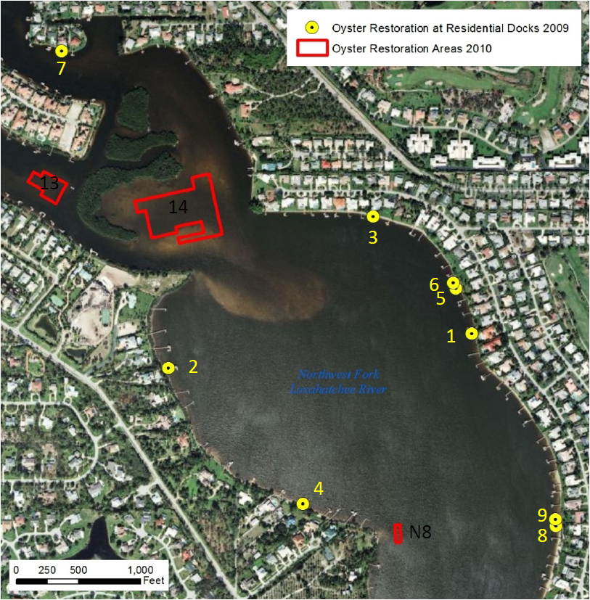

There’s a co-partnership in place with Palm Beach County with efforts towards a beach restoration project in Juno Beach. There’s large rock and shell mixed in with sand dredged onto the beach that the project was not going to use so the material was an 8-mile haul that saved $100,000 to build more habitat.

The project area provides 200 oysters per square meter and seems to be thriving except for Area 14 which seems to have some sedimentation issues.

The latest monitoring study done in March of this year shows a balance between the systems that show density of the oyster populations thriving more in some sections than others but providing a steady habitat development overall in the area.

Oyster bags are being replaced in the residential area all the way up to the sea wall.

Maintaining a variation of material works more appropriately than having a carpet of the same material in the area.

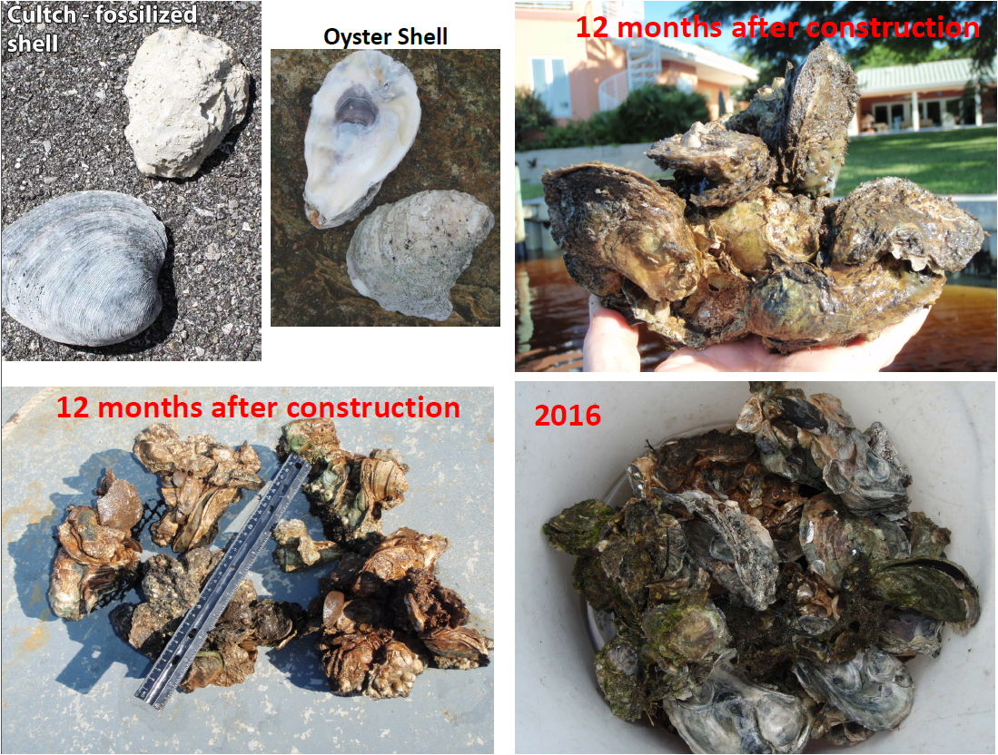

The reason why the area was chosen to develop the project is because it was the most ideal to promote the oyster population to thrive naturally because of the mangroves and other elements with the least sedimentation issues.

- Update on the Impaired Waters RAP - Julie Espy, Program Administrator, Water Quality Assessment Program

Mr. Howard briefly summarized why this effort is preferred to going through a TMDL and FDEP and having a BMAP approved. Via the implementation of the Impaired Waters Program, we can have the community to volunteer to identify the sources of pollution, decide which agency should take over the efforts to determine what to do about it and they have asked the LRMCC (which has agreed) to participate as a leader in our community to put together a restoration plan that FDEP would ultimately approve and forward to agencies for final agreement and implementation. He stated that Lox River is impaired and DEP could move forward with determining a total maximum daily load (TMDL) that will result in a basin management action plan (BMAP) or the community can prepare a RAP. He stated that instead of DEP being heavy-handed, the agency will work with LRMCC on a RAP. The consensus is that the LRMCC will take this on which will likely result in monthly meetings. While there is no absolute deadline for completion of the RAP, DEP wants to see substantial progress between now and December 2016.

Julie Espy, Program Administrator, Water Quality Assessment Program for FDEP, provided a brief summary on the Impaired Waters Program. EPA’s Clean Water Act Section 3-3d is what drives this assessment and TMDL process.

Brief summary about the Watershed Management approach was provided where DEP implements Impaired Waters assessment program as part of the Watershed Management approach. It was started in July 2000 and the Watershed approach established a five-phase cycle that rotates through all basins in the state over five-year period by dividing the State’s basins into groups.

The Watershed Management Cycle includes five phases: Preliminary assessment, targeted monitoring and assessment, develop and adopt TMDLs, Establish TMBL Implementation Strategy and TMDL Implementation.

Within Phase 2 - Targeted Monitoring and Assessment restoration options before going through TMDL and BMAP under the assessment categories (1 – not impaired, 2 – meets standards, not impaired, 3 – Insufficient data to verify, 4 – Does not meet standards but a TMDL is not needed, and 5 – Does not meet standards; impaired by a pollutant).

There are different groups that provide monitoring (75 different data providers) to do assessments. All the information on monitoring station location information and FDEP associates the information and this is used to be presented in their assessment. The data is then run through a computer program has implemented their impaired waters rule standards. The data collection is done two to three times a year.

A reasonable assurance plan provides an implementation schedule and resource commitments that there are or will be pollutant loading reductions that will result in a water body achieving water quality targets to attain and maintain the ones in use.

The expectations from the agency regarding the Reasonable Assurance Plans are:

- Description of Impaired Waterbody
- Description of Water Quality or Aquatic Ecological Goals
    - The water quality–based targets or aquatic ecological goals (both interim and final) that have been established for the pollutant(s) of concern.
- Description of Proposed Management Actions To Be Undertaken
- Schedule for restoration projects, including funding sources
- Description of Procedures for Monitoring and Reporting Results
- Description of and Commitment to Proposed Corrective Actions

Under the basic requirement of description of procedures for monitoring and reporting results it is suggested to continue to maintain and increase your monitoring network. They are critical part of the plan as they contain critical data to be used to measure the plan’s progress. When updates are provided over the years, this is the data that should be provided.

The data must be uploaded to Florida STORET. FDEP will deploy a new database software to be used for the same purposes and transition should be coordinated closely, new database should be available at the beginning of 2017.

FDEPs role in the preparation of this plan is to provide technical support for setting the water quality targets via FDEP contractors and EPA model, assistance with the plan may include facilitation and technical support on water quality targets. The Loxahatchee’s Stakeholder commitments would include: resourcing staffing, funding for restoration projects and monitoring.

The course of action set for this plan is as follows:

- Develop a RA plan
- Submit to the Department for approval
- RA Plan is approved by the Department and adopted by the Secretary (at this stage the plan becomes an enforceable action)
- Updates are provided to the Department based on the schedule established in the Plan
- Updates are reviewed for confirmation of reasonable progress
- Implementation of plan continues until targets are achieved

A document is available for review and reference that contains plans and guidance at: http://www.dep.state.fl.us/water/watersheds/assessment/index.htm

The Chair suggested providing this document to whomever joins this effort and is new to the standards and guidelines set by FDEP as it is a very comprehensive document that makes it easier to understand the RA plan formulation and goals.

Questions/comments by attendees
- Deborah Drum: If water quality deadlines are not met, can DEP take enforcement action? Julie: Corrective actions should be identified in the plan. If corrective actions are not followed, DEP could take enforcement action, but the preference is to work with stakeholders.
- How much oversight by DEP during the RAP process? Can DEP take issue with the schedule? Julie: DEP will provide input; the schedule should reflect reasonable expectations.
- Are the RAP and BMAP mutually exclusive? If we pursue a RAP, then no BMAP? Julie: Correct. If there is no RAP, then DEP will move forward with the TMDL/BMAP process. This is a unique situation in that DEP intended to complete a TMDL for Lox River since U.S. EPA created a model for the Lox River. DEP will continue with the modeling in parallel to the RAP process and will provide modeling input for the RAP.
- Will TMDLs be the water quality targets for the RAP? Julie and Erin: DEP is not completing the TMDL process; however, ongoing modeling will feed into the plan and help with target identification. The RAP is an "alternative TMDL plan."
- Are FDACS BMPs reasonable for this plan? Julie: Yes, but need to make sure that the producers are implementing the BMPs.
- FDACS BMPs are voluntary. Do agriculture producers have to implement them if identified in a RAP? Julie: Agriculture BMPs are mandatory in BMAPs; I am not sure if they are mandatory in RAPs.
- Deborah Drum: In the St. Lucie BMAP, ag producers were required to have projects, like local governments are. FDACS is staffing up its Okeechobee office to make sure notices of intent (NOIs) are implemented. We need to look at legislative changes that will require enforcement of FDACS NOIs to implement BMPs in RAPs, similar to the BMAP process.
- Can DEP implement rule-making that will require enforcement of FDACS NOIs in RAPs? Julie: DEP has the ability to seek legislative changes. Tiffany: However, legislative changes tend to be most successful it brought forward by a stakeholder rather than a state agency.
- Gary Ritter: There is a statute that the ag community is presumed to meet water quality standards if they have an executed NOI or conduct water quality testing.
- Deborah Drum: Regarding the monitoring requirement, does DEP look at the existing network to determine adequacy? Julie: DEP intends for the existing monitoring network to be used. There is not an expectation for an additional or enhanced monitoring network.
- Herb Zebuth: We should not include projects in the plan that are not supported by the responsible entity. This in turn will place more pressure on other entities/stakeholders. Julie: The RAP is a voluntary plan; entities cannot be forced to participate.

Erin Rasnake of the DEP TMDL Program spoke and responded to questions for approximately 20 minutes on water quality modeling and its application in the RAP process. Specific to Lox River, she mentioned that U.S. EPA had a model created in 2012 based on a 2002−2009 data set. Public comments on the model reflected issues; therefore, DEP recently executed an agreement with Dynamic Solutions (DS) to evaluate the model. DEP anticipates receipt of a preliminary findings from DS by July 27th; DEP will finalize objectives for model revisions (such as using newer data) by August 24th. She anticipates it will then take 4−12 months for DS to update the model (correct data gaps, complete model runs). The anticipated model output will be: nutrient concentration, loads to waterbodies, and water quality targets.

In addition to the U.S. EPA model, which is a loading simulation, for this RAP, DEP will also use EFDC (Environment Fluid Dynamics Code) and WASP (Water Quality Analysis Simulation Program) models to look at waterbodies for chlorophyll and nutrient dynamics.

Erin stated that no model is 100% accurate, but provides simulations and hydrographs with real data.

Julie explained that while the U.S. EPA model is being updated, there are actions that can be taken by LRMCC at monthly meetings. For example, the study area boundary needs to be determined, data collection, project identification, etc. However, for some of the RAP components, the model results will be needed.

Questions/comments by attendees
- How did you determine original chlorophyll-a? Julie: It was based on a reference approach. It will be evaluated as part of the model review.
- Tom Howard: Is the model the scientific basis for nutrient loads identified in our RAP? Erin: Yes, the three models will tell us the needed targets. Tiffany: The models are verified with actual data from the Lox Basin.
- Tom Howard: My concern is that if another source for chlorophyll-a is not identified, given that TN and TP are so low, we may conclude that the TP and TN criteria are too high. Erin: The model will not automatically change criteria. Flow, habitat, or ground water could also affect TP and TN.
- Tom Howard: The model will tell us what to cut back? Then our job is to determine how we lower nutrients through the projects? Erin: Correct.
- Dick Roberts: Are flows going to be influenced? Parallel modeling is occurring now which may change the watershed boundaries. Erin: I need to speak with you to understand the concurrent modeling efforts.
- The model will include entire system, not just the impaired waterbodies? Erin: Yes.
- Bud Howard: Please look at the established criteria as it appears to have fallacies (chlorophyll-a too low). Erin and Julie: Yes, we will look at the established criteria.
- Bud Howard: How does this relate to EPA's TMDLs? Alan Wertepny: There was interaction with EPA through the MS4 group. Erin: On EPA's website, look at "adopted" (written and approved by EPA) TMDLs compared to "approved" (written by DEP and approved by EPA) TMDLs.
- Alan Wertepny: Can the Lox River District provide an environmental assessment to help with criteria since chlorophyll-a criteria may be too low? Julie: Chlorophyll-a may not be the right end point, so we will review and discuss the correct end point.
- Bud Howard: Bacteria has been in the news lately. Are you looking at that? Erin: There are no bacteria on the TMDL priority list. Julie: DEP should look at your bacteria data to see if the levels indicate impairments still exist.

Tiffany Busby spent approximately 30 minutes discussing and responding to questions on the logistics of preparing a RAP. She stated that a preliminary list of stakeholders has been prepared based on point source permittees and MS4 permittees identified in the impaired areas. Perhaps there are agricultural operations and water control/improvement districts (Section 298 districts) that are also stakeholders. She asked the attendees if they are aware of other stakeholders that have nutrient discharges/responsibilities. Three districts were mentioned: South Indian River Water Control District, North Palm Beach Water Control District, and Hobe-St. Lucie Conservancy District.

Tiffany reviewed procedures specific to the Lox River RAP. Each entity is responsible for their own information and commitments (not the LRMCC as whole). The RAP must address sources to meet targets. DEP is responsible for plan adoption and U.S. EPA approval.

Tiffany explained the decisions that need to be made during plan development: 1) boundary, 2) water quality targets, 3) adequacy of effort, 4) projects and schedules, and 5) monitoring efforts. Additional stakeholders may be identified upon finalization of the study area boundary.

Tiffany requested the attendees ponder operating procedures: how additional stakeholders should be included in decision-making and if there are other entities that should be invited to the meetings or decision-making.

In light of the numerous questions and comments regarding project funding, Tiffany passed over her slides on project considerations (start date for inclusion, confirmed projects, wish list projects, consistency in estimated reductions, and tools to organize project information).

Tiffany and Tom Howard solicited feedback on the proposed meeting dates of August 1st, August 29th, September 26th, and October 24th. No feedback was received; therefore, Tom took that to mean the LRMCC agrees to RAP meetings on those dates with the following priorities: 1) boundary determination, 2) point source and nonpoint source identification, 3) agency jurisdictions, 4) nutrient sources, and 5) monitoring network.

At the August 1st meeting, Tom Howard wants to review a detailed water quality report for the Lox Basin and determine the study area boundary. Bud and Julie agreed that Julie will summarize water quality data contained in the Florida Storage and Retrieval (STORET) databased for the Lox Basin.

Questions/comments by attendees
- Chad Kennedy: There are existing restoration flow targets. Whatever we do should be consistent with minimum flows and levels (MFLs) and other efforts. Julie: Very good point. This information can be pulled together while the model is being updated.
- Deborah Drum: Regarding adequacy of effort, if an entity indicates lack of funding, is that an acceptable reason for the entity to not be responsible for projects? Julie: Adequate funding is certainly a challenge. Corrective actions in the RAP should address this; schedules can be adjusted based on funding.
- Deborah Drum: We have the St. Lucie and Okeechobee BMAPs in Martin County that identify $150 million projects with no funding. A tax increase is the only answer. Section 298 districts should take notice of this. There are a lot of challenges associated with a RAP or BMAP.
- There is a struggle to fund projects unless DEP is a source of money.
- Deborah Drum: There is not enough money statewide. Local initiatives are drying up. We are setting ourselves up for failure.
- Tom Howard: The RAP by design brings the community together. LRMCC and the RAP itself can be persuasive, but perhaps not in Martin County.
- Deborah Drum: Martin County is committed to the Lox River. I am not saying to not complete the RAP, but eyes need to be wide open. Those at the table need to understand what the process really it is. It always comes down to money.
- Chad Kennedy: Can't we adjust the schedule based on funding? Julie: Yes, the schedule can be adjusted, but DEP needs project commitments.

- Science Symposium – Dick Roberts
Since it’s been five years since the last symposium was organized, it’s important to start focusing on budget funding, possible dates and designating an organization committee.

The last time they symposium was organized, staff was in charge and it proved to be too big of a commitment for them. It was suggested to hire a contractor for distribution of information (FAU took on this task last time) and also to review abstracts, settle on keynote speaker. It was mentioned that the SFWMD gave $5K in support of the symposium the last time.

As there are a lot of projects that are not necessarily new but have just started their implementation/construction stage and this could be a better focus than new science. It would probably be an option to find contractors willing to fund these projects. Then abstracts on District, RECOVBER and CERP projects would be provided and review the level of interest. It was noted to have Kathy query council members and find out which agencies would be interested in providing abstracts to explore possibilities for presentations

- Watershed Status Updates
- Loxahatchee River Dashboard Overview, Albrey Arrington, LRD (5 min)
- Water Quality, Bud Howard, LRD (5 min)

- Member Issues (brief, verbal status update)
- Land Management
- Flood Control
- Environmental Issues
- Recreation Opportunities
- Permits

- Public Comment

- Adjourn

The meeting adjourned at 5:10 PM.

